Step-by-step problem with iOS clent
I have iPhone with iOS 7.1.1 full Czech language

- Create new task with „Due Date“ via icon calendar

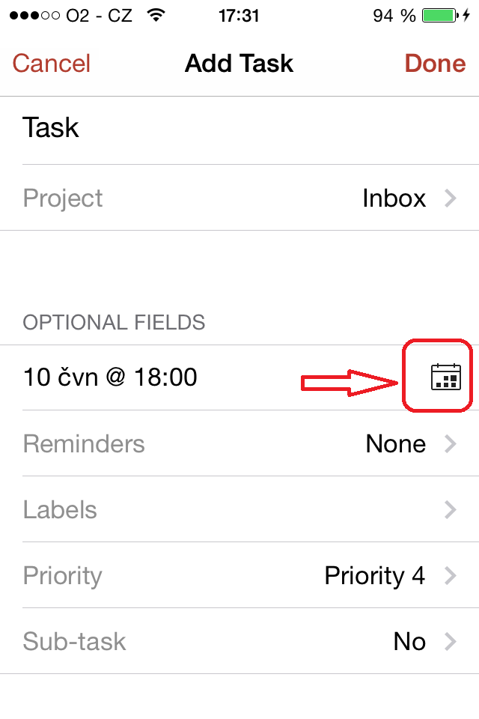

- Click to „Done“ and I see „Error“

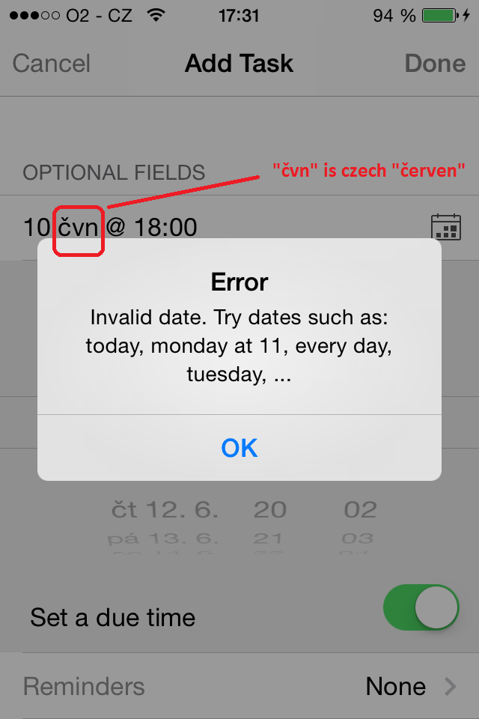
- If the moon "Jun" to change for ”June” after all OK and time/date is accept.

I think. that the problem is in the language of translation, which does not accept Czech Days and months

