WEB VIEW OF A PROJECT WITH SUB-PROJECTS
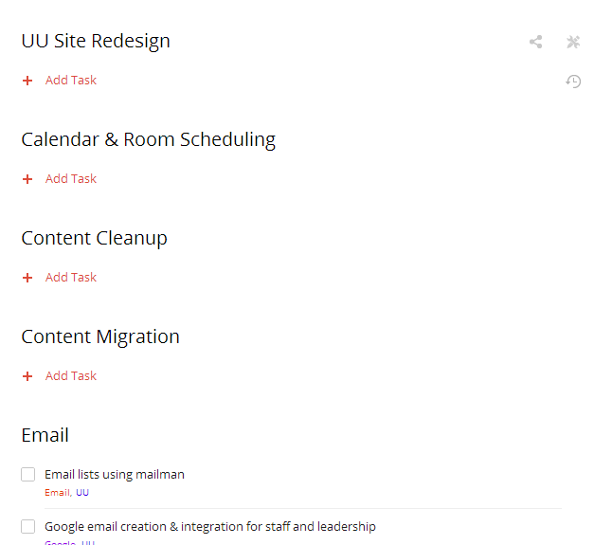

IPAD VIEW OF A PROJECT WITH SUB-PROJECTS
As you can see, the views are very different. Not sure why the ipad does not show the same web view to give a snapshot of the whole project

